


West Coast Collaborative
Specialist Mathematics Units 3 & 4
Investigation 2 2017
A Vector Approach to Closest Approach in 3D
Take Home Section – due Tuesday 25 April
Complete this Take Home Component on file paper showing all working out and reasoning. Use of CAS calculator to aid calculation is assumed. On completion of Part 1 there will be a Validation Task (Part 2). For Part 2, CAS calculators will be allowed but no other notes will be permitted.
Part 1: Take Home Component
1.
Distance between a point and line using the Scalar Product method.
Find the shortest distance from point to the line .

Minimum distance occurs when is perpendicular to line.
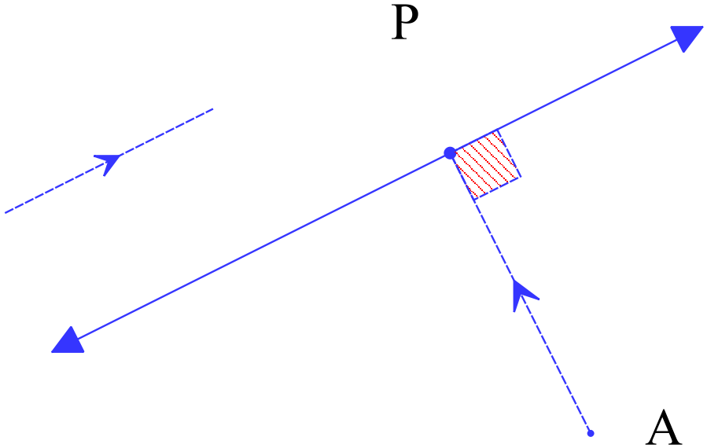Hence, is perpendicular to vector
Since,
As is perpendicular to vector
=
Therefore,
2.
The position vectors (r) and velocity vectors (v) of two ships A and B at 9.00 a.m. on a particular day were as follows:
At 9.00 a.m.
km km/h.

km km/h.
Show that if the two ships continue with these velocity vectors they will collide.
Solution

If t is the number of hours after 9 a.m. then
At t hours past 9 a.m. the respective positions of A and B will be
Position vectors of A and B will have same i component when
i.e. when
Position vectors of A and B will have same j component when
i.e. when

The same i component of position vector occurs at 2.00 p.m. and also the same j component occurs at 2.00 p.m. Thus A and B collide at 2.00 p.m.

The position vectors (r) and velocity vectors (v) of two ships A and B at 9.00 a.m. on a particular day were as follows:
At 9.00 a.m.
km km/h.

km km/h.
3.
Show that if the two ships continue with these velocity vectors their paths will cross but they will not collide.
Solution

If t is the number of hours after 9 a.m. for ship A andis the number of hours after 9 a.m. for ship B. (Why different time values?)
at t hours past 9 a.m. the position of A will be

at hours past 9 a.m. the position of B will be
Position vectors of A and B will have same i component when
i.e. when

Position vectors of A and B will have same j component when
i.e. when

As the times are different it suggests that the two ships will be in the same place at the differing times. Hence, no collision but their paths will cross at the point:

For

For

Hence, we will be in the same palace at different times. Hence, no collision occurs.

4.
Example

Particle P starts moving from a point with position vector < 10, 14 > metres with constant velocitie < 5, 2 > metres per second. P continues with this velocity passing a stationary object at A< 34,12 > metres. Find the closest distance between P and A. State where and when this occurs.
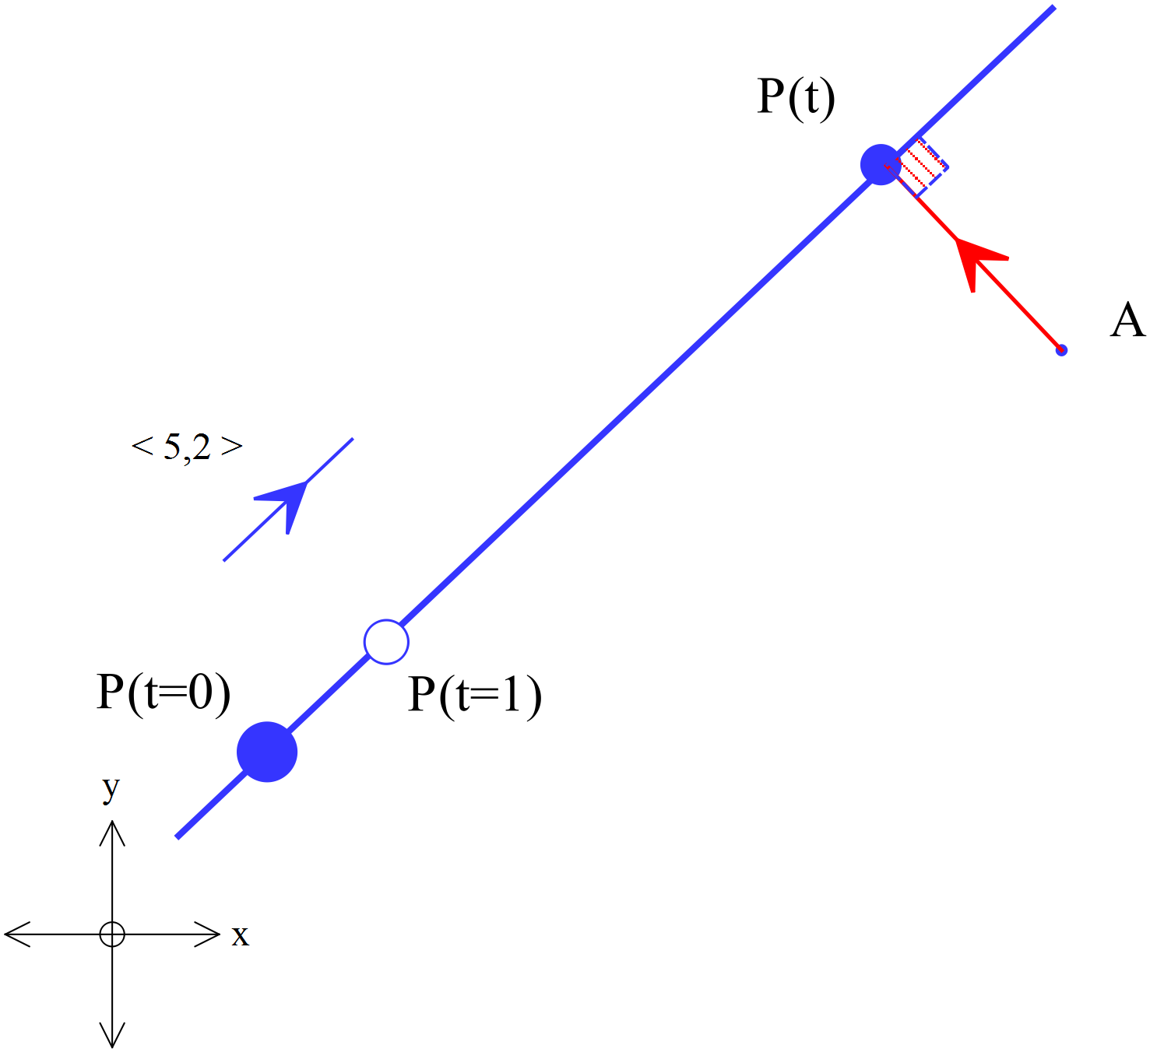Solution:
Assume that P is closest to A at time t.

Velocity vector of P at time t is

Position vector of P at time t is
Position vector of A at time t is

Position of P relative to A at time t,
P will be closest when vector AP is perpendicular to the line!
At closest approach when
Position of P relative to A at time ,
Closest distance is the length of the vector
Hence, closest distance between P and A is m.

Validation Exercise
Problem
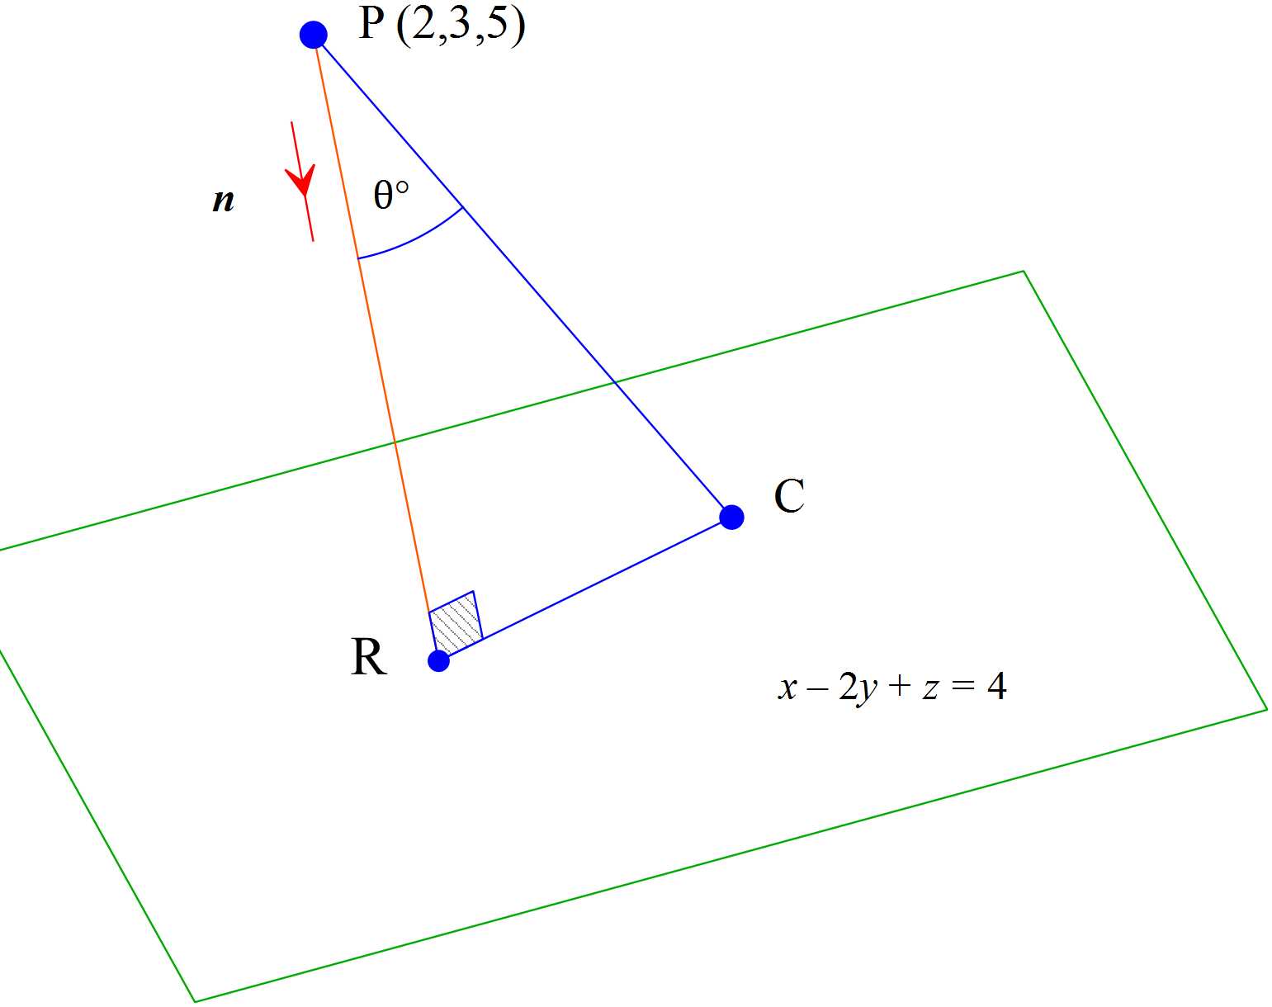
Find the distance from point P (2,3,5) to the plane with vector equation.

Solution
Step One
Find just one point on the plane. e.g. C is (3,1,3) because
Hence
Step Two
Find the unit vector normal to the plane, using a cross product
As and are parallel to the plane it follows that a vector normal to the plane is
As is normal to the plane the unit normal will be:
Since where is a unit normal vector.

Hence,
Distance from a point to a plane (alternative method i)
Determine the shortest distance from the point to the plane .
Let B(a, b, c) be on the plane such that is perpendicular to the plane. i.e will be the minimum distance.

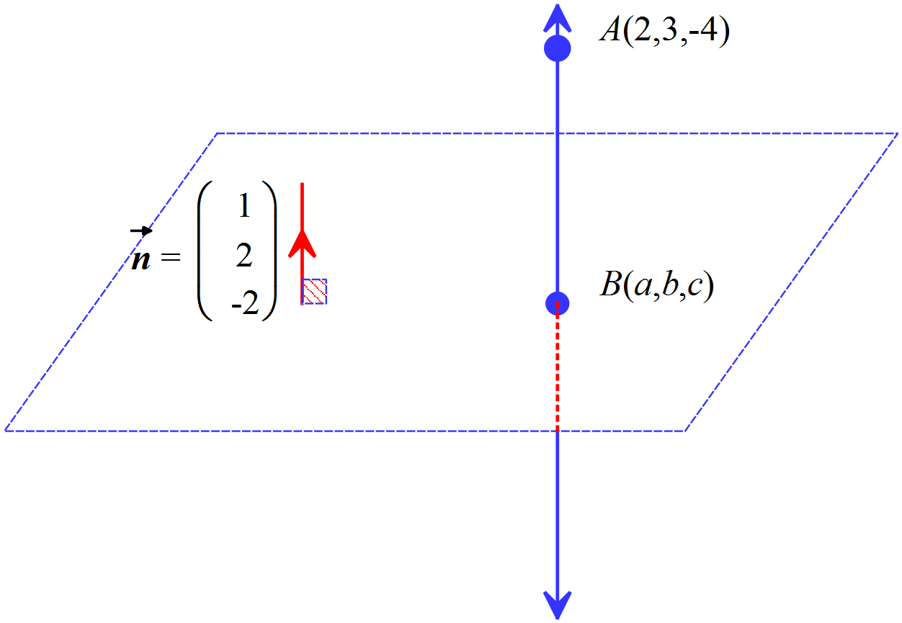Equation of line through A and perpendicular to plane is

At point of intersection B
2 + λ + 6 + 4λ + 8 + 4λ = 7
λ = −1
So for λ = −1, B = =
Therefore =

Distance from a point to a plane (alternative method ii)
Determine the shortest distance from the point to the plane .
Let B(a, b, c) be on the plane such that is perpendicular to the plane. i.e will be the minimum distance.



= $\left(\begin{aligned}a-2 \\ b-3 \\ c+ 4\end{aligned}\right)$

$\left(\begin{aligned}1 \\ 2 \\ -2\end{aligned}\right)$ (normal to the plane.)

$\left(\begin{aligned}a-2 \\ b-3 \\ c+ 4\end{aligned}\right)$ =k $\left(\begin{aligned}1 \\ 2 \\ -2\end{aligned}\right)$

So a − 2 = k, b − 3 = 2k, c + 4 = −2k

Also $\left(\begin{aligned}a \\ b \\ c\end{aligned}\right)$ $\left(\begin{aligned}1 \\ 2 \\ -2\end{aligned}\right) = 7$

a + 2b − 2c = 7 (1.2)

Substituting equations from (1.1) into (1.2)

2 + k + 2(3 + 2k) − 2(− 4 − 2k) = 7
k = −1

Therefore = −1

= $\sqrt{1+4+4}$ = 3 units

